**Topic:** Viete, Napier, Briggs

**Notes on Topic:** The sixteenth and seventeenth century both saw a vast amount of mathematical discoveries and activity, the seventeenth, even overshadowing the sixteenth  
The shift from the past where we saw mostly Greek, some Arabian, and then Italian mathematicians, now we will notice a European trend  
The French, German and British now enter  
Some scholars attribute this to the new freedom of inquiry happening in Northern Europe contrasted with the restrictions of the church in Italy  
For example: Galileo’s imprisonment and disavowal due to his investigating topics that were not accepted by the church would have been enough to silence the community of scholars  
  
The French Mathematician, Francois Viete published the influential, *In Artem Analyticam Isagoge*, meaning The Analytic Art  
Viete was known not only for approximating pi

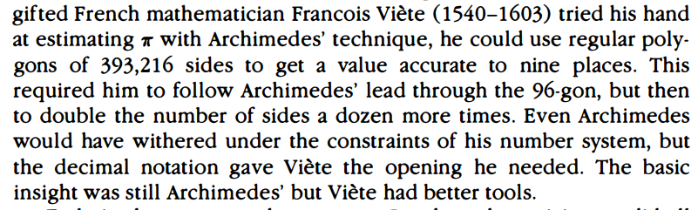  
*In Artem* set the scene for symbolic algebra, although his symbolic algebra still differs greatly from modern day, it was a huge leap nonetheless

“D in R - D in E aequabitar A quad” would mean $DR-DE=A^{2}$, he was the first to use letters to denote quantities in an equation

He also was one of the first to work on the binomial powers which later helped Newton with discovering the binomial theorem  
  
Two mathematicians from the British Isles, John Napier and Henry Briggs perfected the logarithm  
Pierre Simon Laplace later, while studying the works of Napier and Briggs noted, “by shortening the labors doubled the life of the astronomer”

**Additional Suggested Reading**: None

**Assignment:** None